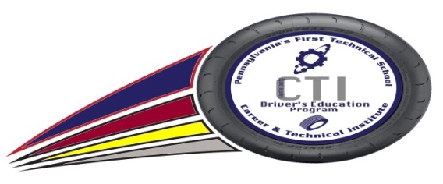
Fayette County Career and Technical Institute

Dr. Cynthia Shaw – Executive Director

The Fayette County Career & Technical Institute offers a complete, state-approved Driver’s Education program. This program is available to all FCCTI students. The course is divided into two sections:

Section 1-Online Driver’s Theory Course
The student completes a driver’s theory course completely online. The course requires at least 30 hours to complete and is accessible from any computer with an internet connection. The student completes the program at their own pace, on their own time. The course consists of nine chapters with corresponding assessments and a comprehensive final exam. Students MUST successfully complete Section 1 of the CTI’s Driver’s Training Program before beginning Section 2.

Section 2-Skills Training
The student receives 6 hours of in-car skills training by a certified driving instructor. The days, times, and number of sessions are flexible but students typically meet the 6-hour requirement over 6 days immediately following the school day in a school vehicle. Sessions are held in Spring and Fall only. Students must complete the online course by May 1st to be eligible for Spring sessions and October 15 for Fall sessions. Students MUST already possess a valid learner’s permit or driver’s license to complete this portion of the program.

Registration
The FCCTI Driver’s Education Program will be available to CTI students for a tuition cost of $20. Fees may be paid using cash, check, or money order and are non-refundable. Make checks payable to Fayette CTI. Certificates of Completion will be issued after both sections of the course have been successfully completed. Check with your individual insurer to determine if a discount is available. To register, return this form, payment, and copy of permit or license (if applicable) to Mr. Justin Grimm. For more information, contact Mr. Grimm at (724) 437-2721 ext. 214.

Do not detach
Last Name | First Name |  | Gender |  | DOB |  | Address
Phone Number(s) | High School |  | Grade |  | CTI Program |  |  | AM / PM
 |  |  |  |  |  |  |  | ☐AM ☐PM
Payment Method ($20) |  | License Status |  |  |  | Copy of Document Attached
☐Cash ☐Check ☐M.O. |  | ☐License ☐Permit ☐None |  |  |  | ☐License ☐Permit ☐N/A
Relevant health/learning conditions instructor should be aware of
Student Email Address (will be used to access online course)
____________________________________________________________________________________________________
Parent/Guardian Email Address
________________________________________________  Parent/Guardian Name (Printed) |  |  |  | __________________________________________________  Parent/Guardian Name (Signature)

