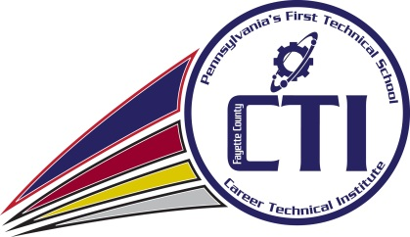
Fayette County Career & Technical Institute Institute
Dr. Cynthia Shaw – Executive Director

TO: All Joint Operating Committee Members
Mr. Christopher Pegg, Chief School Administrator
Dr. Keith Hartbauer, Superintendent
Dr. Jesse T. Wallace, III, Superintendent
Dr. Charles M. Machesky, Superintendent

FROM: Dr. Cindy Shaw, Executive Director

DATE: April 20, 2022

RE: Interviews

A Personnel Committee meeting will be held on Thursday, April 21, 2022, beginning at 5:30 p.m. to discuss the following items:
- Continuing the CTE Instructional Supervisor
- Hiring a Full-time LPN Instructor

Please R.S.V.P. to Lisa Patterson at 724-437-2721, Ext. 107.

